**Mongolian Calcite: The Crystal of Clarity, Calm, and Inner Strength**

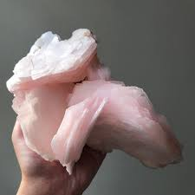

Unlocking the Mystical Power of a Rare and Soothing Gem

By AF Crystal Jewels / Roxy Slabber

**Table of Contents**

1. Introduction
2. What Is Mongolian Calcite?
3. Geological Origins and Rarity
4. Physical Properties
5. Metaphysical and Healing Properties
6. Emotional and Spiritual Benefits
7. How to Use Mongolian Calcite
8. Crystal Pairings
9. Cleansing and Charging
10. Meditation and Rituals
11. Affirmations for Mongolian Calcite
12. How to Identify Authentic Mongolian Calcite
13. Care, Storage, and Maintenance
14. Incorporating Mongolian Calcite in Daily Life
15. Conclusion

**1. Introduction**

Crystals are more than just beautiful formations of the Earth—they are storied allies in healing, clarity, and transformation. One such underappreciated yet incredibly powerful gem is Mongolian Calcite. With its silky hues of creamy white, peach, pink, or icy blue, this rare calcite variant is both a visual delight and a metaphysical powerhouse.

Whether you are new to crystal healing or a seasoned collector, Mongolian Calcite offers a gentle yet potent energy that promotes mental clarity, emotional balance, and spiritual awakening. This eBook will guide you through everything you need to know about this exceptional crystal—from its origins to its everyday applications.

**2. What Is Mongolian Calcite?**

Mongolian Calcite is a rare form of calcite mineral found primarily in the remote, mineral-rich regions of Mongolia. While calcite is common across the world, the Mongolian variety is celebrated for its silky luster, translucent quality, and unusually calming energy. Available in various shades, Mongolian Calcite often appears in milky white, soft peach, rose-pink, and sometimes icy blue tones, making it both an aesthetic and energetic treasure.

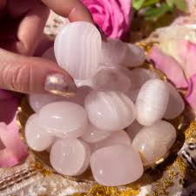

**3. Geological Origins and Rarity**

Mongolia, with its harsh climate and untapped geology, has yielded some of the world’s most exquisite mineral specimens. Mongolian Calcite forms in limestone caves and sedimentary rock beds, growing over thousands of years. Its rarity stems from:

* Limited extraction areas within Mongolia
* High-quality crystallization uncommon in other calcites
* Minimal commercial mining due to the country’s rugged terrain

This makes Mongolian Calcite a collector’s item as well as a sought-after tool in energetic work.

**4. Physical Properties**

|  |  |
| --- | --- |
| **Property** | **Details** |
| Crystal System | Trigonal (Rhombohedral) |
| Hardness (Mohs) | 3 |
| Transparency | Translucent to opaque |
| Lustre | Vitreous to silky |
| Colour Variants | White, peach, pink, blue, ivory |
| Cleavage | Perfect in three directions |

It is soft and should be handled with care. Due to its perfect cleavage, it can split easily under pressure.

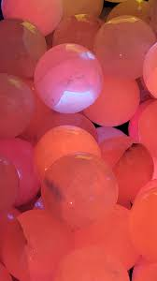

**5. Metaphysical and Healing Properties**

Mongolian Calcite is revered for its high-frequency energy, promoting:

* Mental clarity and focus
* Deep emotional healing
* Gentle purification of negative energy
* Opening of the crown and third eye chakras
* Enhancement of spiritual vision and psychic abilities

This crystal is a balancer, aligning the emotional and mental fields while creating a serene inner space ideal for meditation, channelling, and healing.

**6. Emotional and Spiritual Benefits**

Emotionally, Mongolian Calcite works as a gentle stabilizer. It can:

* Ease anxiety and panic attacks
* Help overcome grief or emotional fatigue
* Promote forgiveness and release past traumas
* Foster a sense of peace and detachment during stressful periods

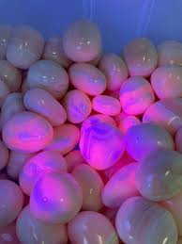

Spiritually, it’s known to:

* Accelerate spiritual growth
* Deepen meditation and visualization practices
* Facilitate connection with angelic realms
* Enhance lucid dreaming and astral travel

**7. How to Use Mongolian Calcite**

Placement Ideas:

* Bedroom: for restful sleep and emotional release
* Meditation altar: to amplify spiritual energy
* Workplace: to encourage calm productivity
* Bath ritual: place nearby (never in water) for emotional detox

Other Uses:

* Worn as jewellery (though fragile)
* Held during breathwork or journaling
* Used in healing grids for clarity or peace

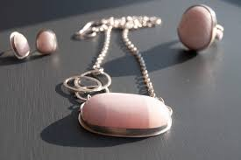

**8. Crystal Pairings**

Mongolian Calcite works well with:

|  |  |
| --- | --- |
| **Crystal** | **Purpose** |
| Selenite | Amplifies purification and angelic connection |
| Amethyst | Deepens intuition and dream work |
| Rose Quartz | Encourages self-love and emotional healing |
| Lepidolite | Combats anxiety and calms the nervous system |
| Celestite | Aids communication with higher realms |

**9. Cleansing and Charging**

Avoid water due to its softness. Instead:

* Smoke cleanse with sage or palo santo
* Selenite plate overnight
* Full moon light charging
* Visualization: Imagine white light infusing the stone

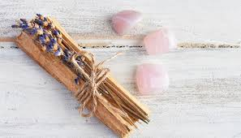

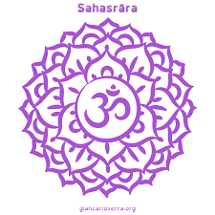**10. Meditation and Rituals**

**Crown Chakra Meditation with Mongolian Calcite**

1. Sit comfortably with Mongolian Calcite on your crown or in hand.
2. Close your eyes and inhale deeply.
3. Visualize a white, silky light flowing from the stone into your body.
4. Repeat the affirmation: “I am open to divine clarity and peace.”
5. Meditate for 10–15 minutes.

**Emotional Release Ritual**

1. Write down the emotions you wish to release.
2. Hold Mongolian Calcite over your heart chakra.
3. Speak aloud: “I let go with love and make space for healing.”
4. Burn the paper (safely) and bury the ashes.



**11. Affirmations for Mongolian Calcite**

Use these affirmations during meditation or daily rituals:

* “I am calm, clear, and in control of my emotions.”
* “Peace flows through me like a river.”
* “I release old wounds and embrace healing.”
* “My spirit is aligned with higher wisdom.”
* “I see the truth with clarity and compassion.”

**12. How to Identify Authentic Mongolian Calcite**

Beware of imitations, especially dyed calcite. Authentic Mongolian Calcite typically has:

* Silky or waxy sheen
* Gentle, natural colours (not neon or overly bright)
* Lightweight feel
* Fine, slightly chalky texture if raw

Buy from trusted sources that disclose origin.

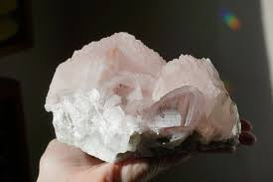

**13. Care, Storage, and Maintenance**

* Store away from harder stones to prevent scratches
* Keep out of prolonged sunlight (may fade)
* Wrap in soft cloth for travel
* Handle gently—avoid dropping

**14. Incorporating Mongolian Calcite in Daily Life**

* Morning Routine: Hold it during journaling or yoga
* Daily Desk Stone: Promotes peace and clarity at work
* Under Pillow: For dream enhancement
* In Crystal Grid: Combine with quartz and amethyst for spiritual awakening
* In Client Healing Sessions: Use over the heart or forehead for emotional release.

**15. Conclusion**

Mongolian Calcite is a gift from the Earth—a rare, gentle, and deeply powerful stone that can guide you toward clarity, inner peace, and higher consciousness. Whether used in healing rituals, meditations, or simply carried for its soothing energy, this crystal offers a sanctuary of light in our fast-paced world.

It is not only a stone of serenity but a teacher of grace—reminding us that true strength lies in calm, clarity, and the courage to heal.