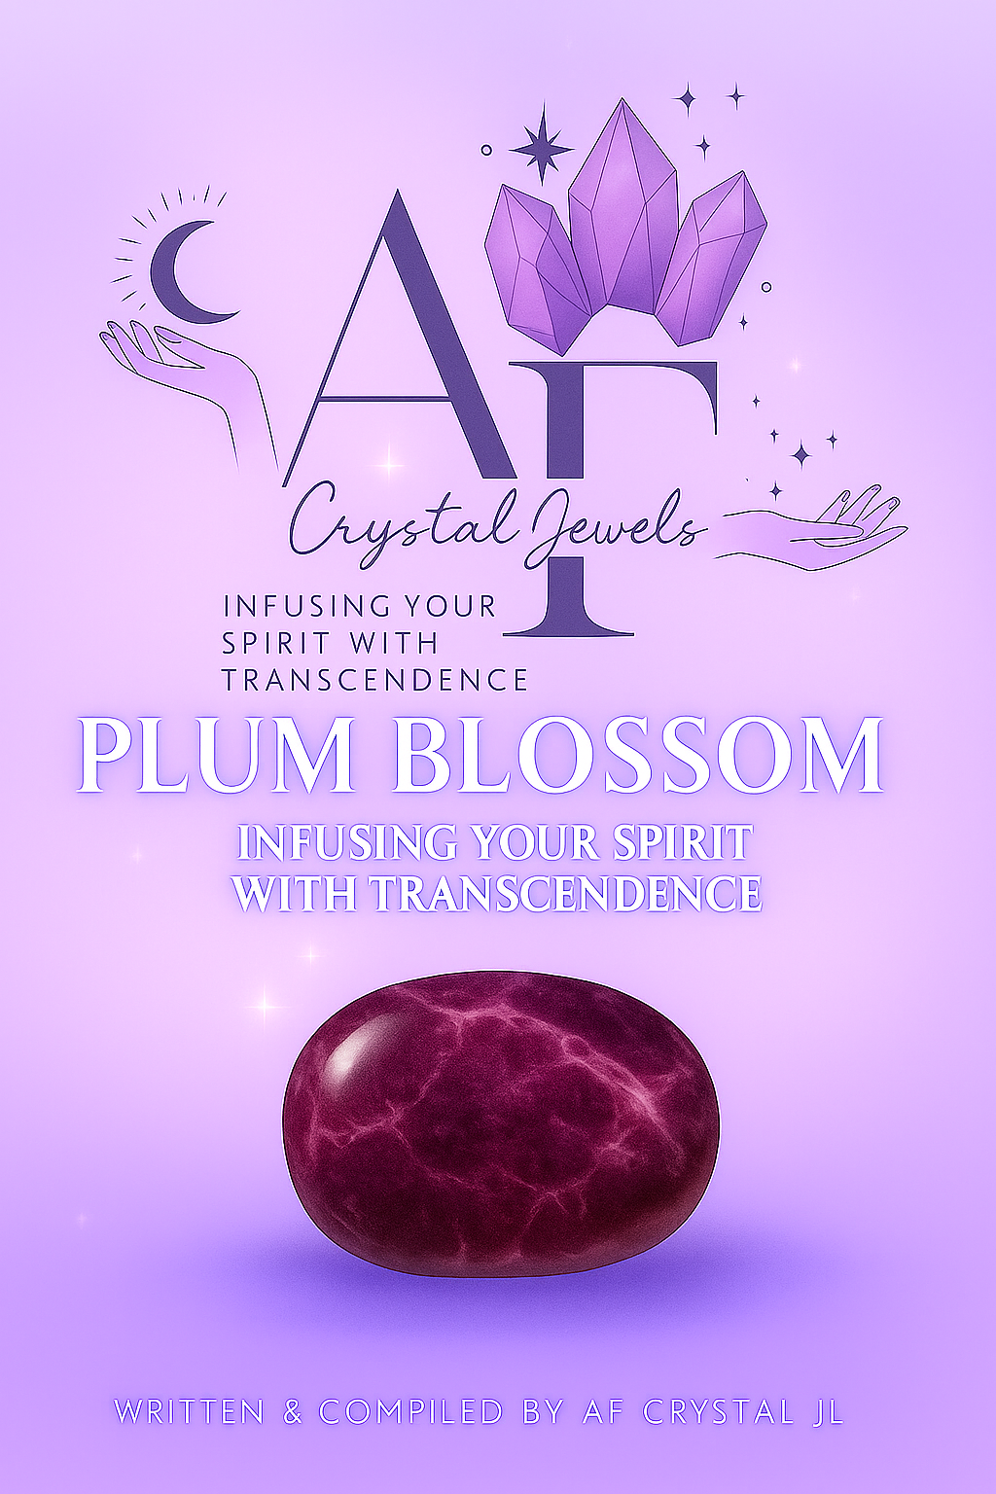
PLUM BLOSSOM JASPER - Infusing Your Spirit with Transcendence
Written & Compiled by AF Crystal JL

Table of Contents
Introduction
The Origins of Plum Blossom Jasper
Geological Composition & Appearance
The Symbolism of Plum Blossoms
Metaphysical Properties
Emotional Healing & Spiritual Growth
Physical Healing Attributes
Chakra Alignment & Energy Flow
How to Use Plum Blossom Jasper
Crystal Pairings for Enhanced Energy
Meditation with Plum Blossom Jasper
Plum Blossom Jasper in Feng Shui
Rituals & Intentions
Affirmations
Cleansing & Charging Your Jasper
Caring for Your Crystal
Final Reflections

1. Introduction
Plum Blossom Jasper is a stone of gentle strength, serenity, and spiritual renewal. With its distinctive floral patterns resembling blossoming plum flowers, it reminds us that even in the depths of winter, beauty and hope can bloom. This crystal carries the nurturing frequency of Mother Earth, encouraging inner peace, balance, and resilience.
Known as the Stone of Rebirth, Plum Blossom Jasper helps the soul to release stagnation and embrace new beginnings with grace and confidence.

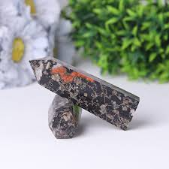

2. The Origins of Plum Blossom Jasper
Plum Blossom Jasper is a rare form of Jasper found primarily in China, India, and Madagascar. It is a silicified chalcedony embedded with intricate flower-like inclusions that naturally form within the stone, creating patterns reminiscent of cherry or plum blossoms.
The blossoms represent renewal and perseverance in Chinese culture, making this crystal not just a geological wonder but a profound symbol of spiritual endurance and hope.

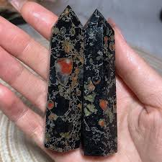

3. Geological Composition & Appearance
Mineral Family: Chalcedony (Microcrystalline Quartz)
Composition: SiO₂ (Silicon Dioxide)
Hardness: 6.5–7 on the Mohs scale
Color Range: Shades of pink, plum, cream, grey, and brown
Pattern: Natural flower-like formations resembling petals in bloom
Each piece is truly one-of-a-kind, carrying the organic imprints of time and Earth’s artistry.
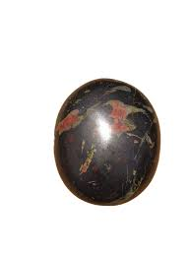

4. The Symbolism of Plum Blossoms
The plum blossom is revered in Eastern philosophy as a symbol of perseverance and purity. It blooms amidst the cold of winter, heralding the arrival of spring — a metaphor for rebirth after hardship.
This symbolism carries through the crystal itself, inspiring endurance, hope, and beauty during life’s challenging transitions.

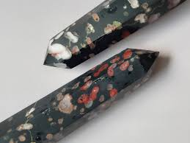

5. Metaphysical Properties
Plum Blossom Jasper embodies calm, grounding, and revitalization. Its energy harmonizes the emotional and physical bodies, promoting gentle transformation.
Key Energies:
Renewal & Rebirth
Grounded Serenity
Inner Strength
Balance & Harmony
Emotional Healing
It reconnects you with your higher self, helping you release old fears and emotional patterns that no longer serve your spiritual path.
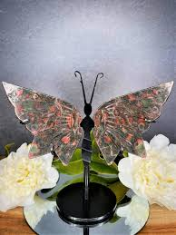

6. Emotional Healing & Spiritual Growth
This crystal encourages emotional release and gentle transformation. It soothes grief, restores confidence, and encourages compassion — both for yourself and others.
It’s particularly helpful for:
Overcoming emotional fatigue
Healing past heartbreak
Reducing anxiety and worry
Cultivating patience and grace
Spiritually, Plum Blossom Jasper fosters acceptance and trust in the divine timing of your life.

7. Physical Healing Attributes
While metaphysical healing is its primary strength, Plum Blossom Jasper is also associated with:
Detoxifying the circulatory system
Supporting skin and cellular regeneration
Enhancing vitality and stamina
Calming the nervous system
It encourages the body to regain equilibrium and vitality through its grounding Earth energy.

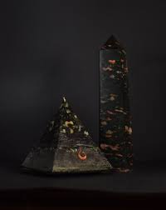

8. Chakra Alignment & Energy Flow
Plum Blossom Jasper aligns primarily with the following chakras:
Root Chakra: For grounding and stability
Heart Chakra: For emotional healing and compassion
Crown Chakra: For spiritual insight and renewal
When meditated upon, it draws energy from the Earth to the higher chakras, creating balance across your energetic field.
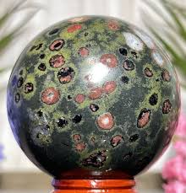

9. How to Use Plum Blossom Jasper
Meditation: Hold it in your left hand to absorb grounding energy.
Jewellery: Wear it close to your heart to enhance emotional balance.
Home Energy: Place it in your sacred space to promote harmony and renewal.
Sleep Aid: Keep under your pillow for peaceful dreams and release of emotional tension.

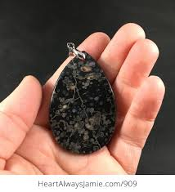

10. Crystal Pairings for Enhanced Energy
Plum Blossom Jasper pairs beautifully with:
Rose Quartz: for compassion and self-love
Amethyst: for higher spiritual connection
Smoky Quartz: for deep grounding and emotional stability
Clear Quartz: for amplification and clarity

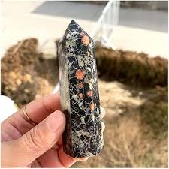

11. Meditation with Plum Blossom Jasper
Meditation Ritual:
Sit in a quiet space with the stone in hand.
Inhale deeply, visualizing soft plum-coloured light surrounding you.
Exhale stress and worry, feeling your energy stabilize.
Repeat the affirmation:
“I am rooted in peace and blossoming into my highest self.”
Allow the stone’s energy to merge with your own, guiding you into tranquillity and renewal.

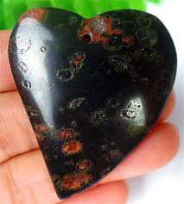

12. Plum Blossom Jasper in Feng Shui
This stone carries a yin energy, promoting peace, feminine strength, and healing.
Place it in the Southwest area of your home to enhance love and relationships.
In the East, it symbolizes new beginnings and personal growth.

13. Rituals & Intentions
Use Plum Blossom Jasper in rituals for:
Letting go of the past
Manifesting emotional renewal
Attracting gentle love and kindness
Welcoming new beginnings
Light a pink or white candle and hold your Jasper as you speak your intention aloud.

14. Affirmations
Use these daily affirmations to align with the energy of Plum Blossom Jasper:
“I release the past and welcome new beginnings.”
“Peace flows through every part of my being.”
“I am strong, serene, and ever-renewing.”
“I am in harmony with the cycles of life.”
“I bloom beautifully, even through challenges.”

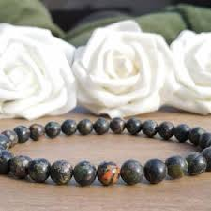

15. Cleansing & Charging Your Jasper
To maintain its energetic purity:
Cleanse: Rinse under lukewarm running water or use sound cleansing (singing bowl or bell).
Charge: Place under the full moon or in morning sunlight for 1–2 hours.
Rejuvenate: Rest on a bed of Clear Quartz or Selenite overnight.

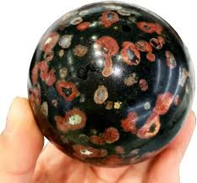

16. Caring for Your Crystal
Avoid prolonged exposure to harsh sunlight or chemical cleaners.
Store in a soft cloth or pouch to protect its polish and energy.

17. Final Reflections
Plum Blossom Jasper is a stone of rebirth — a reminder that beauty and strength coexist in harmony. It helps you transition through life’s seasons with courage and grace, teaching that true growth often blooms from stillness.
When you hold this stone, you hold a fragment of Earth’s patience, beauty, and timeless renewal.

