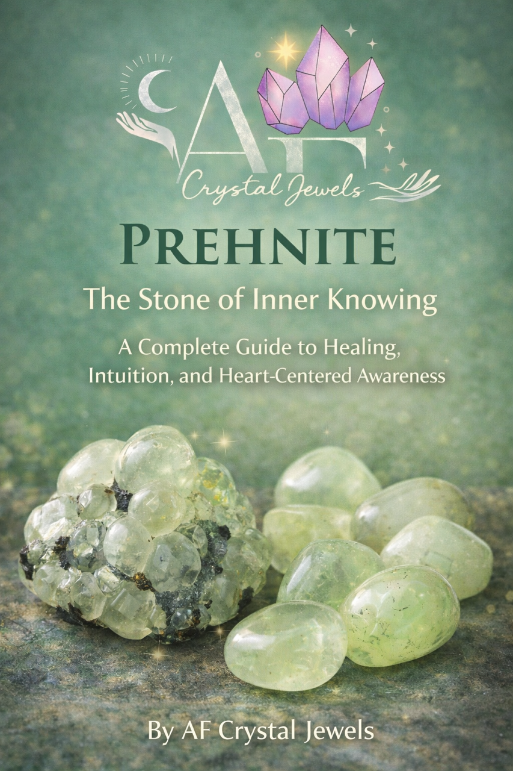
Prehnite: The Stone of Inner Knowing
A Complete Guide to Healing, Intuition, and Heart-Centred Awareness
By AF Crystal Jewels

AF Crystal Jewels. All rights reserved.
No part of this book may be reproduced, distributed, or transmitted in any form without written permission, except for brief quotations used in reviews.
This book is intended for educational and spiritual purposes only and is not a substitute for medical advice.

Contents

- Introduction to Prehnite
- Geological Origins and Mineral Properties
- History and Discovery
- Physical Characteristics and Identification
- Sources Around the World
- Prehnite and Energy Healing
- Chakra Connections
- Emotional Healing with Prehnite
- Prehnite for Spiritual Growth and Intuition
- Prehnite and Meditation Practices
- Prehnite in Crystal Grids
- Combining Prehnite with Other Crystals
- Prehnite for Sleep and Dreamwork
- Protection and Environmental Harmony
- Using Prehnite in Jewellery
- Caring for and Cleansing Prehnite
- Choosing Authentic Prehnite
- Rituals and Daily Practices
- Affirmations for Prehnite
- Final Thoughts

Chapter 1: Introduction to Prehnite
Prehnite is a gentle, yet powerful crystal known for its calming green glow and deeply supportive energy. Often called the Stone of Inner Knowing, it bridges the connection between the heart and higher awareness.
Unlike more intense stones, Prehnite works quietly. Its energy is stabilising, nurturing, and reassuring. Many people experience a sense of peace simply by holding it.
Prehnite teaches trust, trust in yourself, your intuition, and the natural unfolding of life.
It reminds us that clarity already exists within.

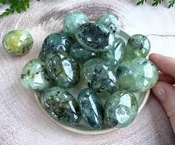

Chapter 2: Geological Origins and Mineral Properties
Prehnite is a calcium aluminium silicate mineral that forms in volcanic rocks, particularly in cavities where mineral-rich fluids have crystallised over time.
Scientific properties:
- Chemical formula: Ca₂Al₂Si₃O₁₀(OH)₂
- Hardness: 6–6.5 on Mohs scale
- Crystal system: Orthorhombic
- Lustre: Vitreous to pearly
- Transparency: Transparent to translucent
It commonly forms in rounded, botryoidal masses, giving it a soft, organic appearance.

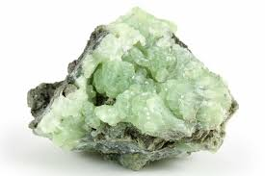

Chapter 3: History and Discovery
Prehnite was first discovered in 1788 in South Africa and named after Colonel Hendrik von Prehn. It was the first mineral ever named after a person.
Historically, it was believed to be used by indigenous healers to enhance communication with spiritual realms and strengthen intuitive awareness.
Today, it remains highly respected among healers and collectors.

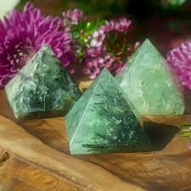

Chapter 4: Physical Characteristics and Identification

Prehnite typically appears as:
• Pale green
• Yellow-green
• Soft apple green
• Occasionally colourless

Common features include:
• Smooth, rounded formations
• Translucent glow
• Waxy or pearly surface
Some specimens contain black epidote inclusions, enhancing both appearance and energetic intensity.

Chapter 5: Sources Around the World
Major deposits include:

- South Africa
- Namibia
- China
- Australia
- United States
- India

South African Prehnite is especially prized for its colour and quality.
Each location produces slightly different energetic qualities, though all share the crystal’s calming nature.

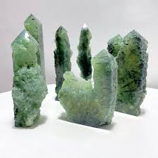

Chapter 6: Prehnite and Energy Healing
Prehnite supports the body’s natural energetic balance.

It helps:
• Calm nervous system tension
• Release energetic blockages
• Restore emotional equilibrium
• Strengthen the auric field
Its frequency promotes gentle but effective healing.

Chapter 7: Chakra Connections
Prehnite resonates primarily with the:
- Heart Chakra
- Third Eye Chakra
Heart Chakra benefits:
- Emotional healing
- Compassion
- Peace
Third Eye benefits:
- Intuition
- Insight
- Spiritual awareness
This unique dual connection allows Prehnite to align intuition with emotional truth.

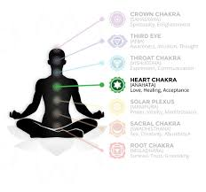

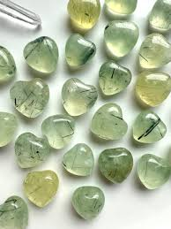
Chapter 8: Emotional Healing with Prehnite
Prehnite helps release:
- Fear
- Worry
- Emotional overwhelm
- Past emotional wound
It replaces these energies with calm and trust.
It is particularly helpful for highly sensitive individuals.

Chapter 9: Prehnite for Spiritual Growth and Intuition
Prehnite enhances:
- Inner knowing
- Spiritual connection
- Intuitive clarity
It helps quiet mental noise, allowing inner guidance to emerge.
Many people report increased synchronicities when working with Prehnite.

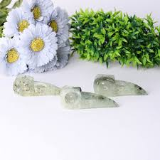

Chapter 10: Prehnite and Meditation Practices
Meditating with Prehnite deepens inner awareness.
Practice:
- Hold Prehnite in your hand
- Close your eyes
- Breathe slowly
- Focus on your heart
Visualise soft green light expanding through your body.
This strengthens calm and clarity.

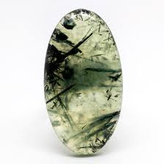

Chapter 11: Prehnite in Crystal Grids
Prehnite works well in grids focused on:
- Healing
- Peace
- Emotional balance
- Intuition
Place Prehnite in the centre of the grid.
Surround with supporting crystals.
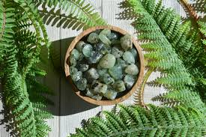

Chapter 12: Combining Prehnite with Other Crystals
Powerful combinations include:
Prehnite and Amethyst
Enhances spiritual awareness

Prehnite and Rose Quartz
Deep emotional healing

Prehnite and Clear Quartz
Amplifies intuition

Prehnite and Labradorite
Strengthens psychic ability

Prehnite and Black Tourmaline
Provides grounding and protection

Chapter 13: Prehnite for Sleep and Dreamwork
Prehnite promotes restful sleep.
Place under pillow or beside bed.
Benefits include:
- Reduced anxiety
- Deeper rest
- Enhanced dream recall
It creates a peaceful sleep environment.

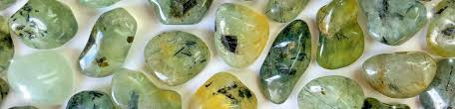

Chapter 14: Protection and Environmental Harmony
Prehnite protects energetic boundaries.
It helps prevent emotional exhaustion.
It also promotes harmony in living spaces.
Ideal for:
- Homes
- Healing rooms
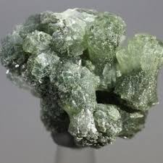
- Meditation spaces

Chapter 15: Using Prehnite in Jewellery
Wearing Prehnite provides continuous energetic support.
Best forms include:
- Pendants
- Bracelets
- Rings
Wearing near the heart strengthens emotional healing.

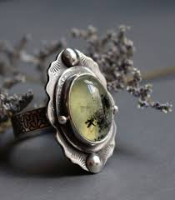

Chapter 16: Caring for and Cleansing Prehnite
Safe cleansing methods:
- Moonlight
- Smoke cleansing
- Sound cleansing
- Selenite charging
Avoid harsh chemicals.
Avoid prolonged water exposure.

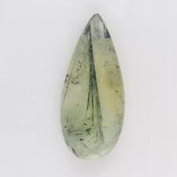

Chapter 17: Choosing Authentic Prehnite
Look for:
Natural inclusions
Soft, glowing colour
Translucency
Avoid overly bright artificial colours.
Trust your intuition when selecting crystals.

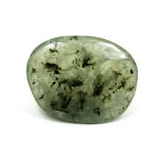
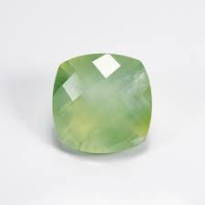

Chapter 18: Rituals and Daily Practices
- Simple daily ritual:
- Hold Prehnite
- Set intention
- Take three slow breaths
- Carry throughout the day.
This strengthens energetic alignment.

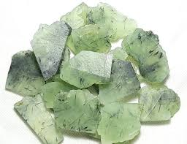

Chapter 19: Affirmations for Prehnite
I trust my inner guidance.
I am calm and balanced.
My heart and mind are aligned.
I am safe and supported.
Clarity flows through me.

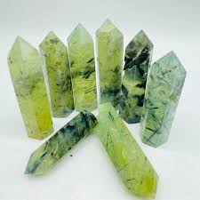

Chapter 20: Final Thoughts
Prehnite teaches gentle strength.
It reminds us that true clarity does not come from force, but from stillness.
Its energy supports emotional healing, intuitive awakening, and inner peace.
Whether worn, carried, or used in meditation, Prehnite becomes a steady companion on the journey toward self-trust and spiritual awareness

