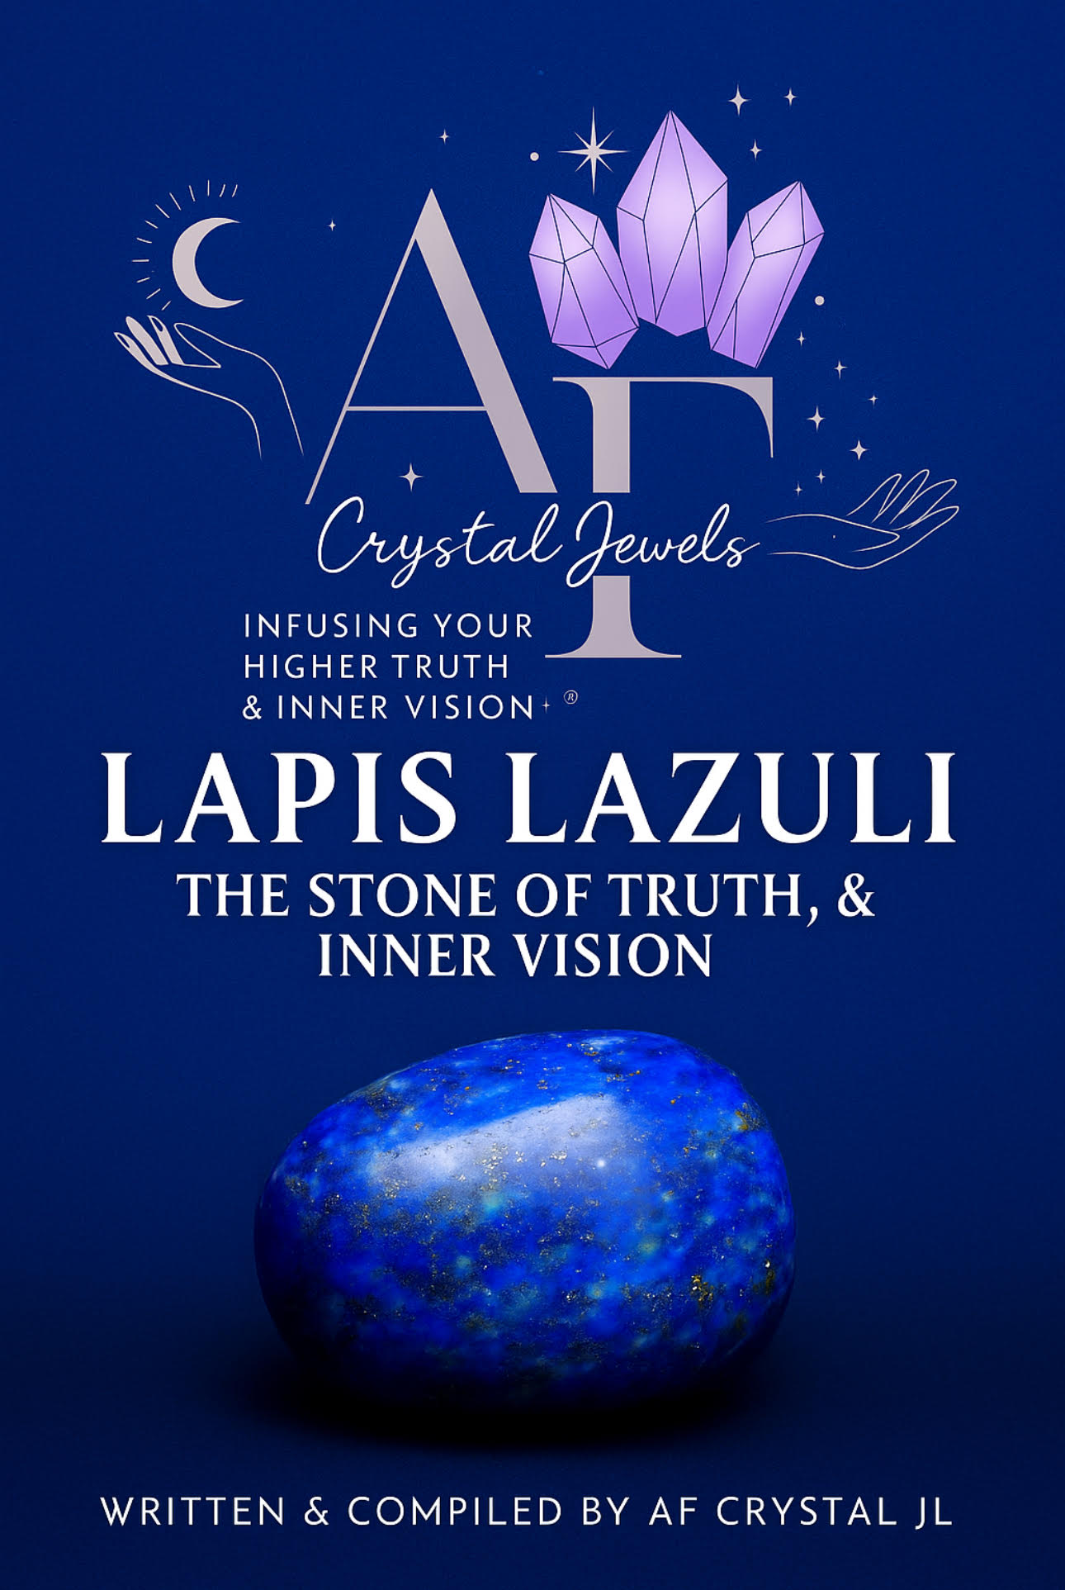
Lapis Lazuli: The Stone of Truth, Wisdom & Inner Vision
By AF Crystal Jewels

Introduction
Lapis Lazuli is one of the most revered and ancient gemstones in human history. Known as the “Stone of Heaven,” it has been treasured for thousands of years for its deep celestial blue hue and its ability to awaken higher consciousness, truth, and inner wisdom.
From the temples of Ancient Egypt to the tombs of Mesopotamia and the frescoes of the Renaissance, Lapis Lazuli has been a symbol of divine insight and spiritual authority. It invites the soul to speak truthfully, see clearly, and align with the inner self.
In this eBook, you’ll discover the origins, metaphysical properties, chakra connections, healing applications, and sacred rituals that make Lapis Lazuli one of the most powerful stones for awakening the voice of truth and intuition.

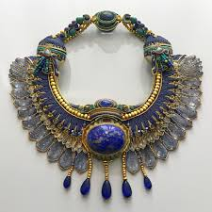

Chapter 1 — The Legacy of Lapis Lazuli
A Gem of Kings, Queens, and Mystics
Lapis Lazuli’s story stretches back more than 6,000 years. It was mined from the mountains of Afghanistan, where its rich indigo colour was seen as a fragment of the night sky fallen to Earth. Ancient civilizations used it for amulets, talismans, and sacred art.
The Egyptians carved scarabs, jewellery, and the famous eye of Horus from Lapis Lazuli, believing it connected the wearer to the gods. Cleopatra was said to have ground it into powder to create her iconic blue eye shadow, linking beauty with divine protection. In medieval Europe, Lapis Lazuli was crushed into ultramarine pigment — more precious than gold — and used by artists to paint the robes of the Virgin Mary, symbolizing purity and divine truth. This stone carries the vibration of spiritual royalty — of speaking with authority, leading with integrity, and seeking truth in all things.

Chapter 2 — Appearance, Composition & Origins
Lapis Lazuli is not a single mineral but a composite stone, primarily made of lazurite, calcite, and pyrite.
Colour: Deep ultramarine blue, often with golden flecks of pyrite that shimmer like stars.
Hardness: 5–6 on the Mohs scale.
Origin: Historically sourced from Afghanistan (Sar-e-Sang mines), also found in Chile, Russia, Pakistan, and the USA.
Each stone is unique — some lighter with cloudy white calcite inclusions, others deep blue and speckled with gold. The most prized specimens are a rich royal blue with minimal calcite and visible pyrite.


Chapter 3 — Metaphysical Properties
Vibration of Truth and Enlightenment
Lapis Lazuli resonates with the Third Eye and Throat Chakras, acting as a bridge between intellect and intuition. Its frequency enhances mental clarity while awakening inner vision and higher understanding.
Key Spiritual Properties:
Stimulates intuition and psychic awareness
Encourages honest self-expression
Promotes deep inner peace and mental clarity
Aids connection with spiritual guides and higher wisdom
Protects against psychic attack and energy manipulation

Emotional Energy:
Lapis Lazuli helps dissolve emotional blockages caused by fear of speaking one’s truth. It brings strength, confidence, and serenity — guiding you to live authentically and communicate with compassion and purpose.

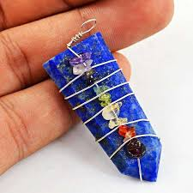

Chapter 4 — Chakra Connections
Throat Chakra (Vishuddha)
Lapis Lazuli is one of the most potent crystals for activating and healing the throat chakra. It removes energetic blocks that prevent self-expression and supports the articulation of thoughts and feelings with clarity and integrity.
When the Throat Chakra is balanced, you speak your truth effortlessly, listen deeply, and express ideas from a place of wisdom rather than ego.
Third Eye Chakra (Ajna) - This stone also awakens the Third Eye — the centre of intuition and higher perception. Through Lapis Lazuli, meditation becomes more profound, visions clearer, and insight more intuitive.
It helps you see beyond illusion and access inner guidance, promoting spiritual awakening and expanded awareness.

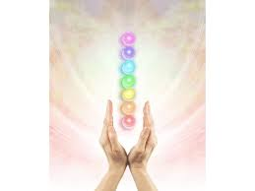

Chapter 5 — Healing Properties
Physical Healing
Lapis Lazuli is believed to:
Support the throat, larynx, and vocal cords
Relieve headaches and migraines
Strengthen the immune system
Regulate thyroid and endocrine function
Aid in overcoming insomnia and stress

Emotional Healing
Emotionally, Lapis Lazuli encourages release from repressed anger or grief. It helps transform frustration into understanding and empowers self-acceptance.

Spiritual Healing
Spiritually, it aligns the mind and soul. It clears confusion and allows for spiritual downloads and revelations — making it an excellent companion for meditation, divination, and astral work.

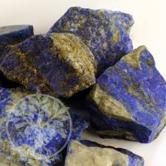

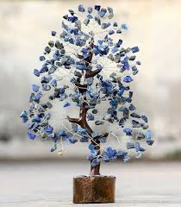

Chapter 6 — How to Use Lapis Lazuli
Daily Practices
Wear it as jewellery: Especially near the throat or third eye area (pendant, earrings, or headband).
Carry it with intention: Keep it in your pocket or purse when entering meetings, interviews, or creative spaces.
Meditate with it: Hold Lapis Lazuli over your third eye and breathe deeply, allowing its frequency to open your inner vision.
Place it on your altar: Invite divine truth and communication energy into your sacred space.

Home & Energy Work
Place Lapis Lazuli in your workspace to promote clear communication and inspiration, or in the bedroom to encourage honest dialogue in relationships.

Chapter 7 — Cleansing & Charging
Lapis Lazuli is a porous stone and should not be cleansed with water or salt.
Safe Methods:
Smudging with sage or palo santo
Sound cleansing using a singing bowl
Moonlight charging (especially under the full moon)
Placing it on a Selenite plate or near Clear Quartz

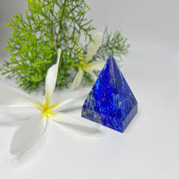

Chapter 8 — Ritual: Awakening Inner Truth
Purpose:
To open the throat and third eye chakras for clarity, truth, and spiritual insight.
You will need:
1 Lapis Lazuli crystal
A blue candle
A small mirror
Frankincense or sandalwood incense
Steps:
Light the candle and incense. Sit comfortably with the Lapis Lazuli in hand.
Gaze into the mirror and look into your own eyes.
Speak aloud:
“I honour the truth within me.
My voice carries wisdom, clarity, and divine light.”
Hold the crystal to your throat and then your forehead, visualizing a blue light expanding through both chakras.
Remain still for a few minutes, allowing messages or insights to rise naturally.
Perform this ritual whenever you need courage to speak from the heart or guidance from higher realms.

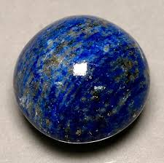

Chapter 9 — Affirmations
Repeat these affirmations daily while holding or wearing Lapis Lazuli:
“I speak my truth with clarity and confidence.”
“My intuition guides me with wisdom and peace.”
“I am aligned with divine truth.”
“I see clearly, and I express myself freely.”
“My words and visions create harmony and light.”

Chapter 10 — Pairing Lapis Lazuli with Other Crystals
Enhance its power by combining it with complementary stones:
Clear Quartz: Amplifies clarity and spiritual communication.
Sodalite: Strengthens rational thinking and communication.
Amethyst: Deepens meditation and spiritual protection.
Pyrite: Grounds intuition with practicality and confidence.
Citrine: Supports self-expression and creativity.

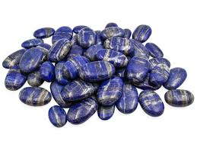

Chapter 11 — Myth, Symbolism & Cultural Significance
In ancient Sumer, Lapis Lazuli symbolized the dwelling of the gods. The priests wore it to channel divine wisdom.
The Persians believed it protected against the evil eye, while Buddhists considered it a stone of inner peace.
Throughout time, it has been linked to royalty, vision, and the pursuit of truth — a timeless reminder that spiritual power begins with self-awareness.

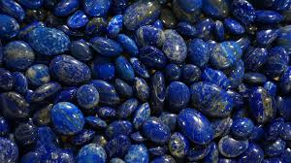

Conclusion
Lapis Lazuli is not just a stone of beauty; it is a teacher. It invites you to embrace truth, seek wisdom, and trust your intuition.
When you connect with its deep celestial energy, you awaken your inner voice — the voice that knows, guides, and empowers.
Let this stone remind you that authentic expression and spiritual insight are your birthrights. Through Lapis Lazuli, you step into clarity, truth, and the boundless wisdom of your soul.



