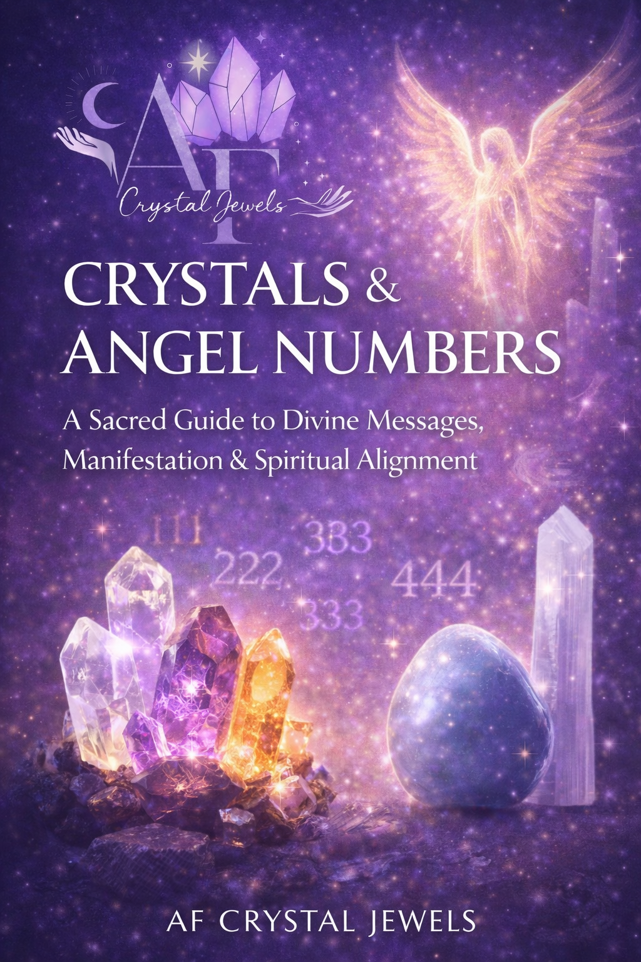
Crystals & Angel Numbers
A Sacred Guide to Divine Messages, Manifestation & Spiritual Alignment

Introduction
Crystals and angel numbers are two of the most powerful spiritual languages available to us. One speaks through the Earth, the other through divine mathematics. Together, they create a system of guidance, healing, and manifestation that bridges the physical and spiritual realms.

This book is designed to help you:
Understand the meaning behind angel numbers
Work with crystals to amplify divine messages
Align your energy with spiritual guidance
Manifest clarity, abundance, protection, and purpose

You do not need prior spiritual experience. All you need is awareness, intention, and openness.

Chapter 1: What Are Angel Numbers?

Angel numbers are repeating or meaningful number sequences that appear intentionally in your life—on clocks, receipts, license plates, phone numbers, and more. These are not coincidences. They are messages from angels, spirit guides, and the higher intelligence of the universe.

How Angel Numbers Communicate

They appear during moments of decision, reflection, or transformation
They repeat until acknowledged
They align with your thoughts or emotional state now you see them

Numbers carry vibration. When repeated, that vibration becomes a message.

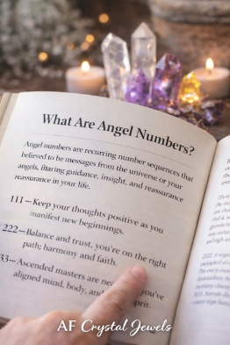

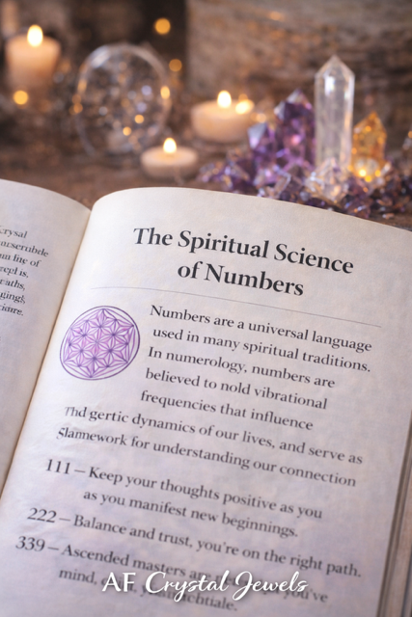

Chapter 2: The Spiritual Science of Numbers
Each number holds a unique energetic frequency.
Number | Core Energy
1 | Divine source, infinite potential
2 | Creation, leadership, new beginnings
3 | Balance, partnership, faith
4 | Expression, creativity, divine support
5 | Stability, protection, foundations
6 | Change, freedom, transformation
7 | Healing, love, responsibility
8 | Spiritual awakening, wisdom
9 | Abundance, power, karma

Completion, humanitarian purpose
When numbers repeat, their message intensifies.

Chapter 3: Why Crystals Amplify Angel Numbers

Crystals are natural conductors of energy. Each crystal vibrates at a specific frequency that can:
Ground angelic messages into the physical world
Strengthen intuition and awareness
Anchor intentions into matter
When you pair a crystal with an angel number, you create energetic alignment—turning messages into action.
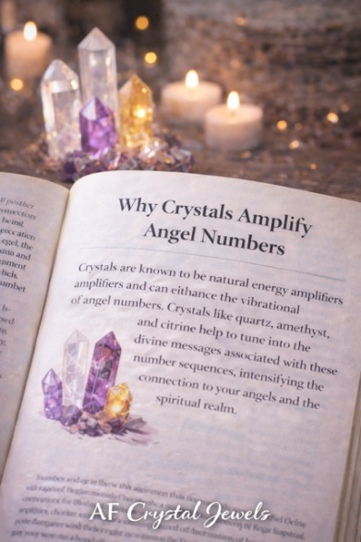

Chapter 4: Angel Number 111 – Manifestation & New Beginnings

Message: Your thoughts are manifesting rapidly. Stay focused.
Best Crystals for 111
- Clear Quartz – manifestation amplifier
- Citrine – confidence and abundance
- Sunstone – leadership and vitality
Affirmation: “I align my thoughts with my highest good.”
Practice: Hold Clear Quartz while visualizing your intention for 3 minutes immediately after seeing 111.

Chapter 5: Angel Number 222 – Alignment & Trust

Message: Everything is unfolding as it should. Trust the process.
Best Crystals for 222
- Rose Quartz – emotional balance
- Moonstone – divine timing
- Lepidolite – peace and reassurance
Affirmation: “I trust the divine plan unfolding for me.”

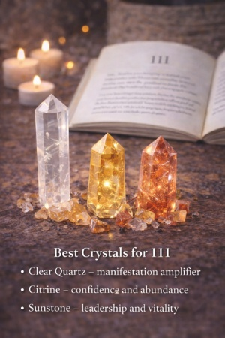
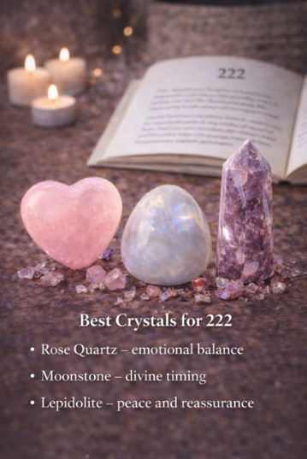

Chapter 6: Angel Number 333 – Divine Support

Message: Ascended masters and guides are nearby.

Best Crystals for 333
- Amethyst – spiritual connection
- Selenite – angelic communication
- Angelite – higher guidance
Practice: Meditate with Selenite above the crown chakra while asking for clarity.

Chapter 7: Angel Number 444 – Protection & Stability

Message: You are surrounded by protection. Keep building.
Best Crystals for 444
- Black Tourmaline – protection
- Smoky Quartz – grounding
- Hematite – stability
Affirmation: “I am safe, supported, and divinely protected.”

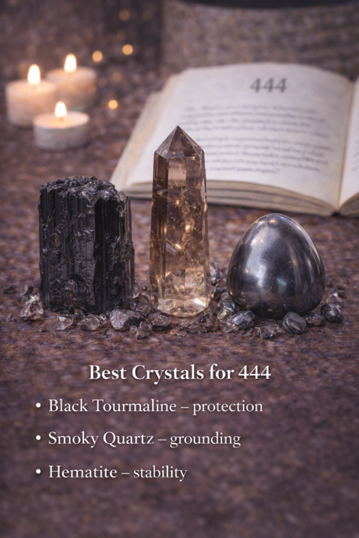
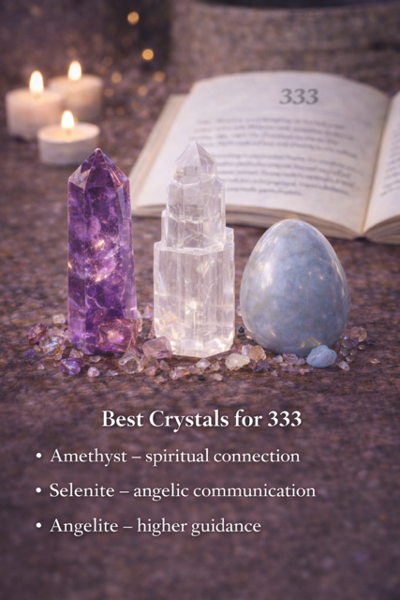

Chapter 8: Angel Number 555 – Transformation & Change

Message: Major life changes are imminent.
Best Crystals for 555
- Labradorite – transformation
- Malachite – courage through change
- Fluorite – clarity
Practice: Write what you are releasing while holding Malachite.

Chapter 9: Angel Number 666 – Realignment & Healing

Message: Shift focus from fear to love. Rebalance.
Best Crystals for 666
- Rhodonite – emotional healing
- Green Aventurine – heart alignment
- Rose Quartz – self-love
Affirmation: “I return to balance, love, and harmony.”

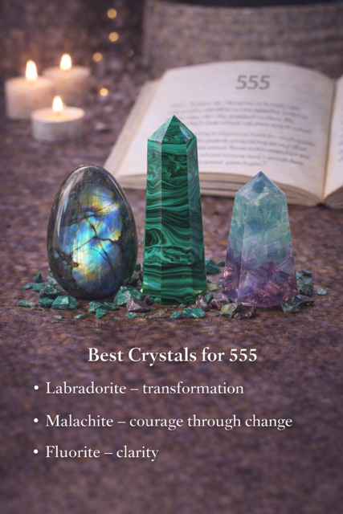
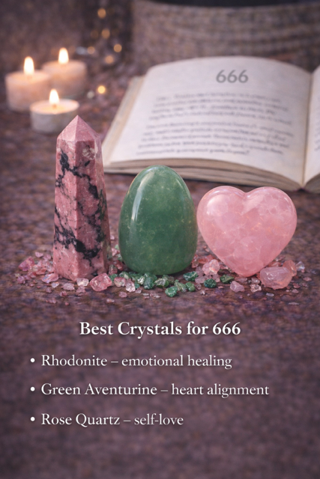

Chapter 10: Angel Number 777 – Spiritual Awakening

Message: You are on the right spiritual path.
Best Crystals for 777
- Amethyst – enlightenment
- Clear Quartz – higher wisdom
- Charoite – soul evolution

Chapter 11: Angel Number 888 – Abundance & Karma

Message: Financial and energetic rewards are flowing.
Best Crystals for 888
- Citrine – wealth
- Pyrite – prosperity
- Tiger’s Eye – confidence
Affirmation: “Abundance flows to me effortlessly.”

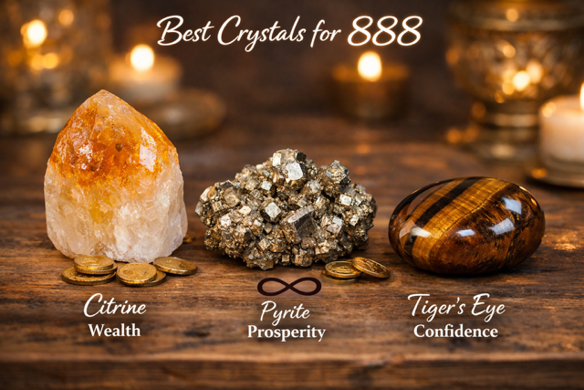
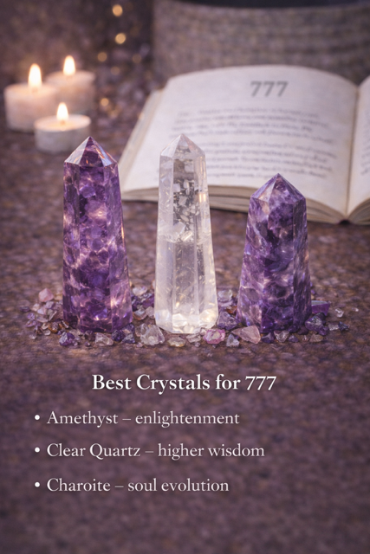

Chapter 12: Angel Number 999 – Completion & Ascension

Message: A chapter is ending. Your soul mission is activating.
Best Crystals for 999
- Labradorite – higher purpose
- Obsidian – release
- Amethyst – transition

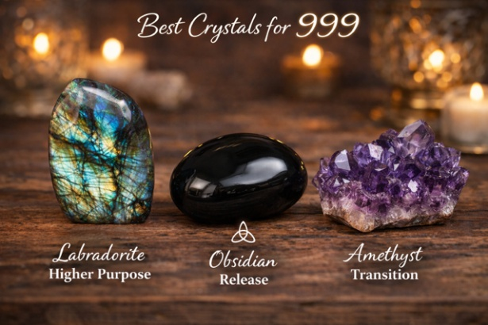

Chapter 13: Creating Angel Number Crystal Rituals

- Simple Ritual Formula
- Notice the number
- Identify the message
- Select aligned crystal
- Set intention
- Anchor with affirmation
Best Time: Immediately after seeing the number.

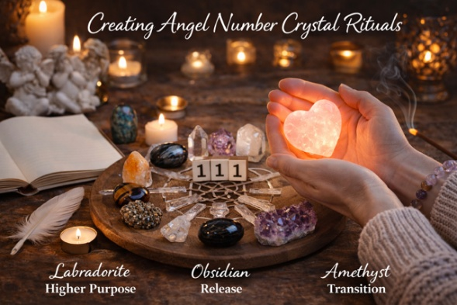

Chapter 14: Angel Numbers in Dreams & Meditation
Angel numbers may appear:
- In dreams
- During meditation
- In automatic writing
Keep a spiritual journal to track patterns and meanings.

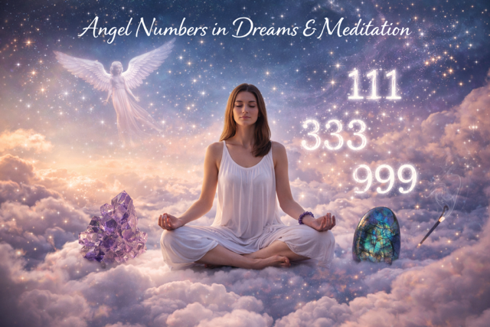

Chapter 15: Signs You Are Becoming More Aligned

- Increased synchronicities
- Repeating numbers daily
- Heightened intuition
- Emotional clarity
- Strong pull toward certain crystals

These are confirmations—not coincidences.



Chapter 16: Caring for Your Crystals

- Cleanse weekly (smoke, moonlight, sound)
- Program intentionally
- Store respectfully
- Trust your intuition
Crystals respond to attention and purpose.

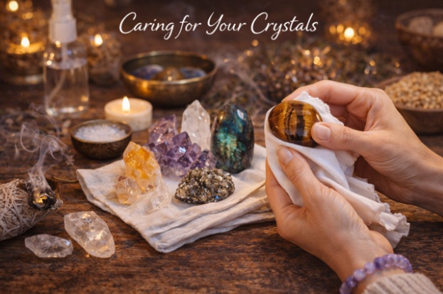

Chapter 17: Final Words
Angel numbers guide. Crystals amplify.
Together, they create a sacred language designed specifically for you.
When you slow down, notice patterns, and work intentionally with energy, the universe responds.
You are never alone. You are always guided.



Printable Angel Number Cheat Sheets - Quick Divine Guidance at a Glance

How to Use These Cheat Sheets
- Notice the number sequence
- Read the core message
- Pair with the recommended crystal
- Repeat the affirmation once or three times
- Take aligned action within 24 hours

000 — Divine Reset
Message: You are connected to Source. Infinite potential surrounds you.
Focus: Spiritual alignment, surrender, fresh starts
Crystals: Clear Quartz, Selenite
Affirmation: “I trust divine intelligence completely.”

111 — Manifestation Portal
Message: Your thoughts are creating reality rapidly.
Focus: Intentions, mindset, leadership
Crystals: Clear Quartz, Citrine, Sunstone
Affirmation: “I consciously create my reality.”

222 — Alignment & Trust
Message: Everything is unfolding in perfect timing.
Focus: Faith, balance, relationships
Crystals: Rose Quartz, Moonstone, Lepidolite
Affirmation: “I trust the process of my life.”

333 — Divine Support
Message: You are surrounded by guides and ascended masters.
Focus: Creativity, communication, soul expression
Crystals: Amethyst, Angelite, Selenite
Affirmation: “I am divinely supported and guided.”
444 — Protection & Stability
Message: You are protected. Build strong foundations.
Focus: Security, discipline, structure
Crystals: Black Tourmaline, Smoky Quartz, Hematite
Affirmation: “I am safe and divinely protected.”

555 — Transformation
Message: Major changes are necessary and beneficial.
Focus: Release, growth, freedom
Crystals: Labradorite, Malachite, Fluorite
Affirmation: “I welcome positive change.”

666 — Realignment
Message: Shift from fear to love. Restore balance.
Focus: Healing, self-care, emotional clarity
Crystals: Rhodonite, Rose Quartz, Green Aventurine
Affirmation: “I choose balance, love, and peace.”

777 — Spiritual Awakening
Message: You are on the correct spiritual path.
Focus: Inner wisdom, intuition, soul growth
Crystals: Amethyst, Clear Quartz, Charoite
Affirmation: “I honour my spiritual journey.

888 — Abundance & Karma
Message: Financial and energetic rewards are flowing.
Focus: Prosperity, confidence, success
Crystals: Citrine, Pyrite, Tiger’s Eye
Affirmation: “Abundance flows to me effortlessly.”

999 — Completion & Soul Mission
Message: A chapter is ending; your higher purpose activates.
Focus: Release, transition, service
Crystals: Labradorite, Obsidian, Amethyst
Affirmation: “I release the past and step into purpose.”

Master Numbers (Advanced Cheat Sheet)
11:11 — Awakening Gateway
Message: You are spiritually activated.
Crystals: Clear Quartz, Moldavite
Affirmation: “I am aligned with my higher self.”

22:22 — Master Builder
Message: Your visions are becoming reality.
Crystals: Pyrite, Hematite
Affirmation: “I build my dreams with clarity and power.”

33:33 — Master Teacher
Message: You are here to uplift and guide others.
Crystals: Amethyst, Blue Lace Agate
Affirmation: “I serve with love and wisdom.”

Quick Reference Summary Table
NUMBER | THEME | ACTION
111 | MANIFEST | FOCUS THOUGHTS
222 | TRUST | STAY PATIENT
333 | SUPPORT | EXPRESS YOURSELF
444 | PROTECTION | STAY DISCIPLINED
555 | CHANGE | RELEASE RESISTANCE
666 | BALANCE | RETURN TO LOVE
777 | AWAKANING | FOLLOW INTUITION
888 | ABUNDANCE | RECEVE CONFIDENTLEY
999 | COMPLETION | LET GO

