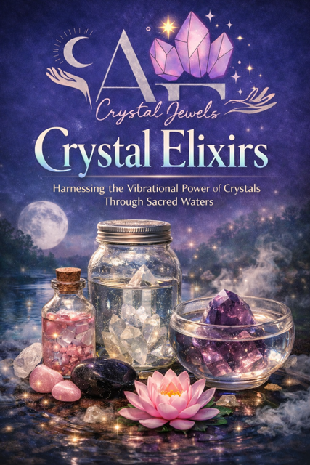
Crystal Elixirs
Harnessing the Vibrational Power of Crystals Through Sacred Waters
Copyright Page
© 2026 AF Crystal Jewels
All rights reserved. No part of this book may be reproduced, distributed, or transmitted in any form without prior written permission from the publisher.
This book is for spiritual and educational purposes only. Crystal elixirs are not intended to diagnose, treat, cure, or prevent any medical condition. Always use discernment and consult a qualified professional when needed.

Table of Contents
Introduction to Crystal Elixirs
The Sacred Relationship Between Water & Energy
How Crystal Elixirs Work
Energy, Intention & Vibrational Medicine
Direct vs Indirect Crystal Elixirs
Crystal Safety: Stones That Are Safe & Unsafe
Preparing Yourself & Your Space
Cleansing & Charging Crystals for Elixirs
Programming Crystal Elixirs with Intention
How to Make a Crystal Elixir (Step-by-Step)
Moon-Charged & Sun-Charged Elixirs
Elixirs for the Chakras
Elixirs for Emotional Healing
Elixirs for Love & Self-Worth
Elixirs for Abundance & Manifestation
Elixirs for Protection & Energy Clearing
Elixirs for Spiritual Awakening
Daily Rituals Using Crystal Elixirs
Combining Crystals, Herbs & Flower Essences
Storing, Using & Respecting Your Elixirs
Advanced Elixir Practices
Closing Blessing

1. Introduction to Crystal Elixirs
Crystal elixirs are one of the most ancient and subtle ways of working with crystal energy. Long before modern metaphysics, healers understood that water could hold memory, intention, and vibrational imprint.
A crystal elixir is water that has been energetically infused with the frequency of a crystal, allowing that vibration to be absorbed gently through the body, aura, and consciousness.
This practice is not about consuming minerals—it is about receiving information.

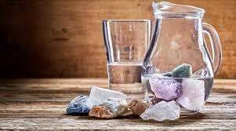

2. The Sacred Relationship Between Water & Energy
Water is a living conductor. It responds to:
- Thought
- Emotion
- Sound
- Intention
- Frequency
The human body is over 70% water, making us exceptionally receptive to vibrational remedies. When water is infused with crystal energy, it becomes a bridge between Earth’s intelligence and human consciousness.
This is why elixirs feel gentle yet profound.

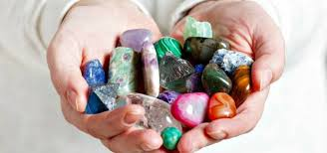

3. How Crystal Elixirs Work
Crystals emit stable vibrational frequencies formed over thousands—or millions—of years. When placed near or within water, their energetic pattern is transferred through resonance.
The water does not absorb the physical crystal—it absorbs its energetic blueprint.
When consumed or applied:
- The body recognizes the frequency
- The nervous system softens
- Energetic imbalances begin to recalibrate

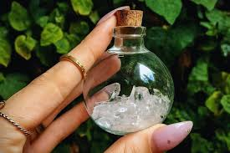

4. Energy, Intention & Vibrational Medicine
Crystal elixirs are most effective when paired with intention.
Intention acts as a directional force, guiding the crystal’s frequency toward a specific outcome:
- Healing
- Clarity
- Emotional balance
- Manifestation
Without intention, an elixir is still active—but intention refines its purpose.

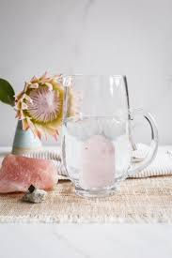

5. Direct vs Indirect Crystal Elixirs

Indirect Method (Recommended & Safest)
The crystal never touches the water.
Place the crystal in a glass container
Set that container inside or beside a larger water vessel
The energy transfers without physical contact

Direct Method (Advanced Use Only)
The crystal is placed directly into the water.
This method is only safe for non-toxic, stable stones and requires expert knowledge.
For most practitioners, the indirect method is preferred.

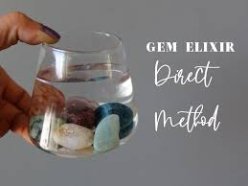
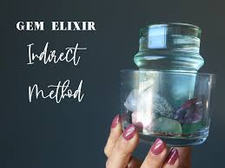

6. Crystal Safety: Stones That Are Safe & Unsafe
Commonly Safe Crystals (Indirect Method Still Preferred):
- Clear Quartz
- Rose Quartz
- Amethyst
- Smoky Quartz
- Citrine (natural)

Crystals That Should NEVER Touch Water Directly:
- Malachite
- Azurite
- Selenite
- Pyrite
- Galena
- Fluorite
- Copper-based stones
When in doubt: always use the indirect method.

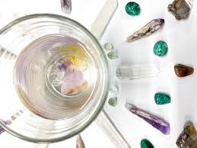

7. Preparing Yourself & Your Space
Before making an elixir:
- Ground yourself
- Clear distractions
- Clean your physical space
- Set a calm, intentional atmosphere
Your energetic state directly influences the outcome.

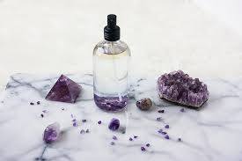

8. Cleansing & Charging Crystals for Elixirs
Crystals must be energetically clean before use.
Methods include:
- Moonlight
- Sound (singing bowls, bells)
- Smoke (incense, palo santo)
- Visualization
Avoid water cleansing unless the crystal is water-safe.

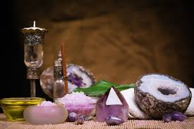

9. Programming Crystal Elixirs with Intention
Hold the crystal and speak or think your intention clearly.
Examples:
“This elixir supports emotional healing and peace.”
“This water carries the frequency of love and self-worth.”
Clarity matters more than complexity.

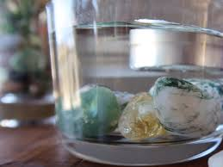

10. How to Make a Crystal Elixir (Step-by-Step)
Cleanse your crystal
Place it in a small glass container
Set that container into a larger glass jar of filtered water
Set your intention
Leave for 4–12 hours
Thank the crystal and water
Your elixir is now ready.

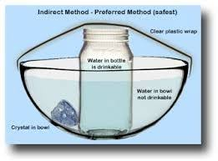

11. Moon-Charged & Sun-Charged Elixirs
Moon-Charged Elixirs
- Emotional healing
- Intuition
- Feminine energy
Best made during full or new moons.

Sun-Charged Elixirs
- Confidence
- Vitality
- Manifestation
Charge for short periods to avoid energetic overload.

12. Elixirs for the Chakras
Each chakra responds to specific crystal frequencies.

Examples:
Root: Smoky Quartz, Hematite
Heart: Rose Quartz, Rhodonite
Third Eye: Amethyst, Lapis Lazuli
Crown: Clear Quartz, Amethyst
Sip slowly and consciously.

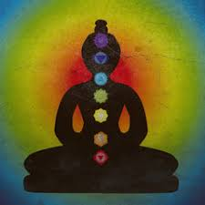

13. Elixirs for Emotional Healing
Crystals such as:
- Rose Quartz
- Rhodonite
- Pink Amethyst
Support emotional release, forgiveness, and inner safety.

14. Elixirs for Love & Self-Worth
These elixirs help dissolve self-judgment and attract aligned relationships.
Recommended stones:
- Morganite
- Kunzite
- Rose Quartz
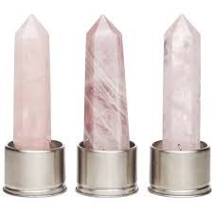

15. Elixirs for Abundance & Manifestation
Crystals that support prosperity:
- Citrine
- Pyrite (indirect only)
- Green Aventurine
Use alongside affirmations and inspired action.

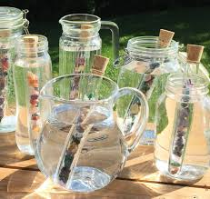

16. Elixirs for Protection & Energy Clearing
Protective stones include:
- Black Tourmaline
- Obsidian
- Smoky Quartz
Ideal before or after social interactions.

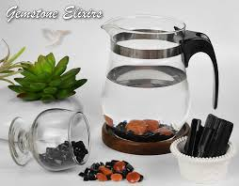

17. Elixirs for Spiritual Awakening
High-frequency stones:
- Amethyst
- Clear Quartz
- Phenakite (advanced practitioners)
Use sparingly and with grounding practices.

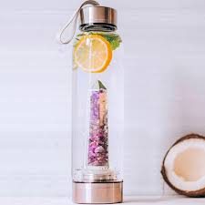

18. Daily Rituals Using Crystal Elixirs
- Morning intention setting
- Pre-meditation sipping
- Energy resets during the day
- Evening emotional clearing
Consistency amplifies results.
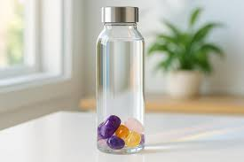

19. Combining Crystals, Herbs & Flower Essences
Crystal elixirs may be combined with:
- Herbal infusions
- Flower essences
- Essential oil aromas (external use only)

Always keep combinations simple and intentional.

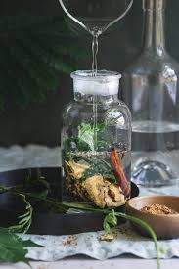

20. Storing, Using & Respecting Your Elixirs
- Store in glass bottles
- Refrigerate if desired
- Use within 24–48 hours
- Never microwave
Treat elixirs as sacred tools.

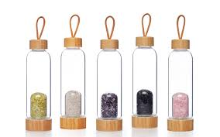

21. Advanced Elixir Practices
Advanced users may explore:
- Grid-charged elixirs
- Seasonal elixirs
- Planetary-aligned elixirs
- Affirmation-coded elixirs
These practices deepen spiritual mastery.

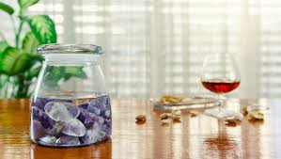

22. Closing Blessing
May every drop you create carry intention, clarity, and healing.
May water remember love.
May crystals remind you of your power.
You are the alchemist.

