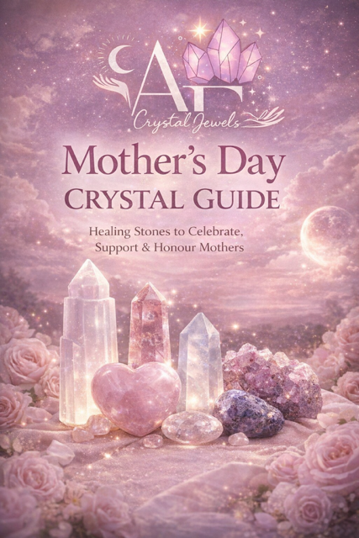
Mother’s Day Crystal Guide
Healing Stones to Celebrate, Support & Honour Mothers
A heart-centred guide to crystals that nurture love, strength, and emotional balance.

Introduction
Motherhood is one of the most powerful expressions of love and devotion. Whether someone is a mother, a grandmother, a mother-figure, or someone who nurtures others through care and compassion, the role carries deep emotional energy.
Crystals have been used for thousands of years to support emotional wellbeing, spiritual growth, and energetic balance. Certain stones resonate especially strongly with the nurturing, loving, and protective energy associated with motherhood.
This guide explores beautiful crystals that make meaningful gifts for Mother’s Day and offers simple ways to use them in rituals, meditation, and everyday life.

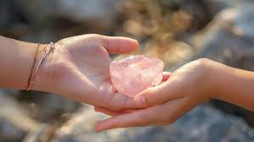

Chapter 1
The Energy of Motherhood
The energy of motherhood embodies several powerful qualities:

• Unconditional love
• Emotional support
• Protection
• Patience
• Strength
• Compassion
• Intuition
These qualities align closely with the heart chakra, the energetic centre associated with love, empathy, and emotional connection.
Many crystals that resonate with Mother’s Day energy are heart-healing stones that encourage emotional harmony and gentle nurturing vibrations.

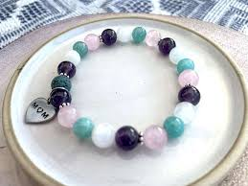

Chapter 2
Rose Quartz — The Crystal of Unconditional Love
Rose Quartz is perhaps the most iconic crystal associated with love and nurturing energy.
Spiritual Meaning
Rose Quartz carries a soft, compassionate vibration that encourages kindness, emotional healing, and self-love.
Why It’s Perfect for Mothers
Motherhood often involves giving endless love to others. Rose Quartz reminds mothers to also give love to themselves.
It supports:
• Emotional healing
• Self-care
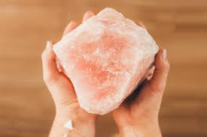
• Harmony in family relationships
• Compassion and forgiveness

How to Use
• Place under a pillow for peaceful sleep
• Keep on a bedside table
• Wear as jewellery close to the heart

Affirmation
“I am surrounded by love and I give love freely.”

Chapter 3
Moonstone — The Divine Feminine Stone
Moonstone is deeply connected with feminine energy, intuition, and emotional balance.
Spiritual Meaning
This mystical stone resonates with lunar energy and the cycles of life. It supports emotional harmony and inner wisdom.
Benefits for Mothers
Moonstone encourages:
• Emotional balance
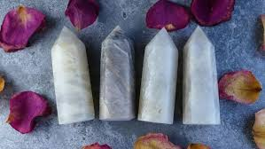
• Intuition and inner guidance
• Calm during stressful moments
• Connection with feminine strength

How to Use
• Carry during meditation
• Keep near a journal for reflection
• Use during moon rituals
Affirmation
“My intuition guides me with wisdom and love.”

Chapter 4
Rhodonite — The Stone of Compassion
Rhodonite is a powerful heart-healing crystal that supports emotional growth and forgiveness.
Spiritual Meaning
It helps release emotional wounds and encourages deeper compassion and understanding.
Why Mothers Love It
Rhodonite promotes:
• Patience
• Emotional balance
• Forgiveness in relationships
• Healing of past emotional pain

How to Use
• Place on the heart during meditation
• Carry during difficult emotional moments
• Use during journaling for emotional clarity

Affirmation
“My heart is open, compassionate, and strong.”

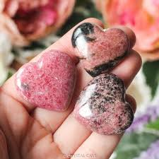

Chapter 5
Amethyst — The Crystal of Peace and Protection
Amethyst is known for its calming and protective energy.
Spiritual Meaning
It helps quiet the mind, relieve stress, and support spiritual clarity.
Benefits for Mothers
Amethyst is ideal for mothers who juggle many responsibilities and need moments of calm.
It encourages:
• Stress relief
• Mental clarity
• emotional balance
• spiritual connection

How to Use
• Place beside the bed
• Hold during meditation
• Keep on a desk for calming energy

Affirmation
“I am calm, protected, and supported.”

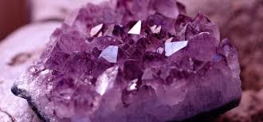

Chapter 6
Pink Amethyst — The Gentle Healer
Pink Amethyst carries a softer, more nurturing vibration than traditional purple amethyst.
Spiritual Meaning
It encourages emotional healing, compassion, and self-acceptance.
Why It’s a Beautiful Gift for Mothers
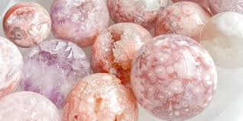
Pink Amethyst supports:
• emotional comfort
• inner peace
• spiritual healing
• loving self-reflection

Affirmation
“My heart is peaceful and filled with love.”

Chapter 7
Mother’s Day Crystal Ritual
A simple ritual can help mothers reconnect with their inner strength and emotional balance.
What You Need
• Rose Quartz
• Amethyst
• A candle
• A quiet space

Steps
Light the candle and take a few deep breaths.
Hold the Rose Quartz over the heart.
Reflect on love received and love given.
Hold the Amethyst and focus on calm and peace.
Repeat the affirmation:
“I honour my strength, my love, and my nurturing spirit.”
Sit quietly for a few minutes and allow the energy of the crystals to settle.

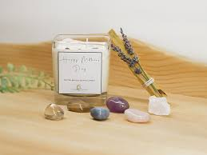

Chapter 8
Crystal Gift Ideas for Mother’s Day
Crystals make meaningful and lasting gifts because they carry both beauty and intention.
Popular Mother’s Day crystal gifts include:
• Rose Quartz hearts
• Crystal bracelets
• Moonstone jewellery
• Amethyst clusters
• Crystal sets for self-care rituals
Pairing crystals with a handwritten affirmation or intention card makes the gift even more personal.

Chapter 9
Honouring All Types of Mothers
Mother’s Day can mean different things to different people.
It can honour:
• Mothers
• Grandmothers
• Stepmothers
• Mother figures
• Women who nurture others
• Mothers who are no longer with us
Crystals can be a beautiful way to reflect, remember, and express gratitude.

Conclusion
Motherhood is a sacred expression of love, care, and strength.
Crystals remind us that nurturing energy deserves to flow both outward and inward. By working with gentle stones like Rose Quartz, Moonstone, and Amethyst, mothers can reconnect with their own emotional wellbeing while continuing to share love with the world around them.
Whether given as a gift or used in personal rituals, crystals offer a beautiful way to honour the heart of motherhood.

