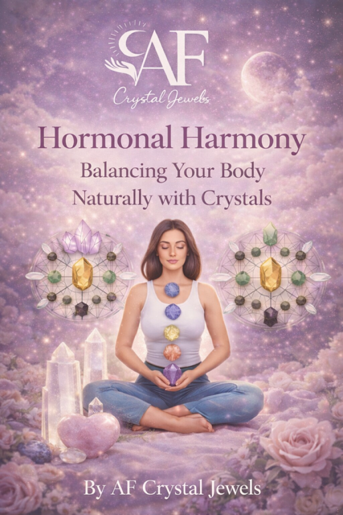
Hormonal Harmony: Balancing Your Body Naturally with Crystals
By AF Crystal Jewels

Contents
- Introduction to Hormones & Energy
- Understanding the Endocrine System
- The Mind-Body-Energy Connection
- Root Causes of Hormonal Imbalance
- Crystals & Their Energetic Influence
- Key Hormones and Crystal Support
- Chakra-Hormone Alignment
- Daily Crystal Rituals for Hormonal Balance
- Moon Cycles & Hormonal Health
- Crystal Grids for Hormonal Healing
- Emotional Healing & Hormones
- Nutrition, Lifestyle & Crystal Synergy
- Hormone-Specific Crystal Protocols
- Affirmations for Hormonal Alignment
- 30-Day Hormonal Healing Plan
- Final Thoughts

1. Introduction to Hormones & Energy
Hormones are the body’s chemical messengers, regulating everything from mood and metabolism to sleep and reproduction. When balanced, they create harmony. When disrupted, they can lead to fatigue, anxiety, weight changes, and emotional instability.
From an energetic perspective, hormones are deeply influenced by emotional states, stress levels, and energetic flow through the body. This is where crystals become powerful allies.
Crystals work on a vibrational level, interacting with the body’s subtle energy fields to restore balance, calm the nervous system, and support natural healing processes.
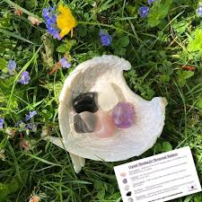

2. Understanding the Endocrine System
The endocrine system is a network of glands that produce hormones:
Hypothalamus – regulates the entire system
Pituitary gland – the “master gland”
Thyroid – metabolism and energy
Adrenals – stress response
Pancreas – blood sugar balance
Ovaries/Testes – reproductive hormones
Each gland corresponds to an energetic centre (chakra), meaning physical and energetic healing must work together.

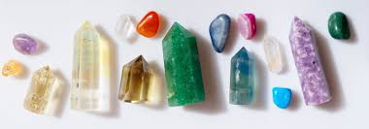

3. The Mind-Body-Energy Connection

Stress is one of the biggest disruptors of hormonal health.
When the body is in constant “fight or flight” mode:
- Cortisol rises
- Progesterone drops
- Thyroid slows
- Sleep is disrupted

Crystals help regulate this by:
- Calming the nervous system
- Reducing emotional overload
- Restoring energetic flow

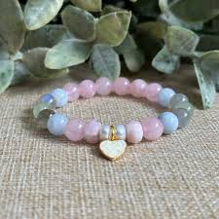

4. Root Causes of Hormonal Imbalance
Common causes include:
- Chronic stress
- Poor diet
- Lack of sleep
- Environmental toxins
- Emotional trauma
- Sedentary lifestyle
Energetically, blocked chakras can mirror these imbalances.

5. Crystals & Their Energetic Influence
Crystals emit stable vibrational frequencies that interact with the body’s energy field.

They can:
- Absorb negative energy
- Amplify healing intentions
- Restore energetic alignment

Key principles:
- Intention activates the crystal
- Consistency creates results
- Alignment enhances effectiveness

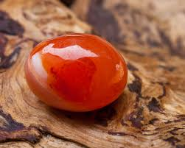

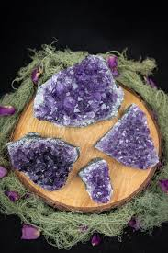
6. Key Hormones and Crystal Support
Cortisol (Stress Hormone)
Amethyst – calming, reduces anxiety
Lepidolite – contains lithium, emotional balance
Smoky Quartz – grounding

Estrogen
Moonstone – feminine energy, cycle regulation
Rose Quartz – emotional healing
Rhodochrosite – heart and hormonal balance

Progesterone
Unakite – reproductive support
Carnelian – vitality and womb energy

Thyroid Hormones
Aquamarine – throat chakra balance
Blue Lace Agate – calming communication

Insulin
Citrine – metabolism and energy
Green Aventurine – overall balance

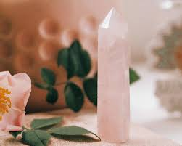

7. Chakra-Hormone Alignment
Each chakra corresponds to hormonal glands:
Root Chakra → Adrenals
Sacral Chakra → Ovaries/Testes
Solar Plexus → Pancreas
Heart Chakra → Thymus
Throat Chakra → Thyroid
Third Eye → Pituitary
Crown → Pineal
Balancing chakras helps regulate hormones naturally.

8. Daily Crystal Rituals for Hormonal Balance

Morning Ritual
Hold Citrine or Carnelian
Set intention: “My body is balanced and energised”

Midday Reset
Carry Amethyst or Lepidolite
Take 3 deep breaths holding the crystal

Evening Ritual
Place Moonstone near the womb/heart
Reflect and release emotional tension

9. Moon Cycles & Hormonal Health
The moon mirrors the menstrual cycle:
New Moon → Rest & reset
Waxing Moon → Build energy
Full Moon → Peak energy
Waning Moon → Release
Use Moonstone, Selenite, and Labradorite during these phases for alignment.
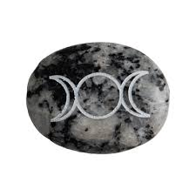

10. Crystal Grids for Hormonal Healing
Create a grid using:
Centre: Moonstone
Surrounding: Rose Quartz, Amethyst, Carnelian
Activate with intention:
“I restore harmony within my body and hormones.”
Place near your bed or meditation space.

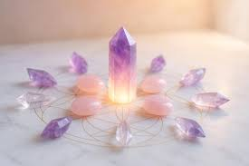

11. Emotional Healing & Hormones
Emotions directly affect hormones.
Unresolved emotions can manifest as:
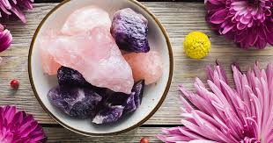
Hormonal acne
Fatigue
Mood swings
Support crystals:
Black Tourmaline – protection
Rhodonite – emotional healing
Clear Quartz – clarity

12. Nutrition, Lifestyle & Crystal Synergy
Crystals work best alongside:
Whole foods
Hydration
Movement
Sleep
Reduced toxins
Think of crystals as amplifiers—not replacements.

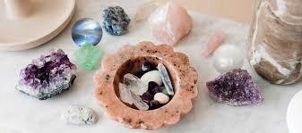

13. Hormone-Specific Crystal Protocols
For Stress & Burnout
Amethyst + Smoky Quartz
Daily grounding meditation

For PMS & Cycle Support
Moonstone + Rose Quartz
Womb placement rituals

For Thyroid Balance
Blue Lace Agate + Aquamarine
Wear near throat

For Energy & Metabolism
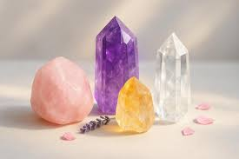
Citrine + Carnelian
Morning activation rituals

14. Affirmations for Hormonal Alignment
“My body is in perfect balance.”
“I trust my body’s natural rhythm.”
“I release stress and welcome calm.”
“My hormones support my wellbeing.”
Repeat daily with your chosen crystals.

15. 30-Day Hormonal Healing Plan

Week 1: Awareness
Track symptoms
Start morning crystal ritual

Week 2: Alignment
Introduce chakra work
Use Moonstone and Amethyst daily

Week 3: Activation
Add crystal grid
Increase affirmations

Week 4: Integration
Combine all practices
Reflect on changes

Consistency is key.

16. Final Thoughts
Hormonal balance is not just physical—it is emotional, energetic, and spiritual.
By combining:
Conscious lifestyle choices
Emotional healing
Crystal energy
You create a powerful system for long-term wellbeing.
Your body is intelligent.
Your energy is powerful.
Your healing is already within you.

AF Crystal Jewels is dedicated to empowering your spiritual journey through high-vibrational crystals, intentional living, and holistic wellbeing.

