Trolleite: The Crystal of Higher Consciousness & Deep Tranquillity

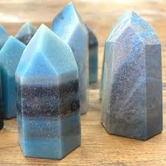

A Complete Guide to Its Meaning, Properties, and Uses

AF Crystal Jewls

Table of Contents

1. Introduction to Trolleite
2. The History & Origins of Trolleite
3. Geological Formation & Characteristics
4. Metaphysical Properties of Trolleite
5. Healing Properties: Mind, Body & Spirit
6. Trolleite and the Chakras
7. Trolleite in Meditation & Spiritual Practice
8. Rituals and Energy Work with Trolleite
9. Trolleite in Crystal Grids
10. Daily Practices with Trolleite
11. Caring for Your Trolleite
12. Pairing Trolleite with Other Crystals
13. Affirmations for Working with Trolleite
14. Using Trolleite in Jewellery & Everyday Life
15. Rare & Collectible Trolleite Varieties
16. Conclusion: Embracing Trolleite’s Energy

Chapter 1: Introduction to Trolleite

Trolleite is a rare and powerful ascension stone, often described as a gateway crystal to higher states of consciousness. Known for its ethereal shades of blue, turquoise, and indigo—often mixed with Quartz, Lazulite, and Scorzalite—it radiates a deeply calming yet spiritually activating energy.

This crystal has gained popularity in modern metaphysics for its ability to aid meditation, spiritual awakening, and emotional healing. Those seeking inner peace, clarity, and a stronger connection with their higher self often find themselves drawn to the mystical vibration of Trolleite.

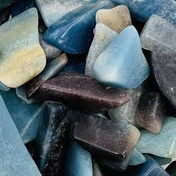

Chapter 2: The History & Origins of Trolleite

Trolleite was first discovered in Sweden in 1868 and named after Swedish chemist Hans Gabriel Trolle-Wachtmeister. For many years, it remained little known in both geology and metaphysical circles due to its rarity.

Significant deposits were later found in Brazil, which is now the main source of gem-quality Trolleite. Smaller occurrences have been reported in the United States, Australia, and Rwanda.

While its mineralogical history is rooted in science, its spiritual history is woven into the growing interest in ascension stones—crystals believed to help humanity evolve into higher states of awareness.

Chapter 3: Geological Formation & Characteristics

Mineral Family: Aluminium phosphate mineral

Composition: Often contains Quartz, Lazulite, and Scorzalite

Color: Shades of blue, indigo, green-blue, and sometimes grey

Hardness: 5.5–6 on the Mohs scale

Crystal System: Hexagonal

Trolleite often forms in massive crystalline structures, with swirling patterns of blue and white that give it a dreamy, celestial quality. Its unique mix of minerals enhances both its beauty and energetic vibration.

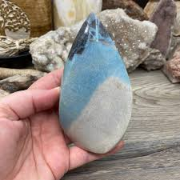

Chapter 4: Metaphysical Properties of Trolleite

Trolleite is revered as a stone of spiritual expansion and deep inner peace. Its key metaphysical properties include:

Awakening higher consciousness

Enhancing intuition and psychic abilities

Promoting tranquillity and emotional balance

Encouraging spiritual discipline and meditation

Assisting with past-life recall and soul healing

It is especially known for gently clearing energetic blockages that prevent growth, making it a powerful ally for those on a spiritual path.

Chapter 5: Healing Properties – Mind, Body & Spirit

Mind

Supports clarity of thought

Eases stress and anxiety

Encourages emotional detachment from negativity

Body

May aid in relieving tension headaches and fatigue

Believed to regulate the nervous system

Supports overall energetic alignment

Spirit

Assists in connecting with guides and higher realms

Helps with past-life exploration

Strengthens meditation and astral travel experiences



Chapter 6: Trolleite and the Chakras

Trolleite works primarily with the Throat, Third Eye, and Crown Chakras, but can activate the entire chakra column for full energetic alignment.

Throat Chakra: Enhances clear communication and truthful expression

Third Eye Chakra: Awakens intuition, insight, and psychic awareness

Crown Chakra: Opens spiritual connection and higher consciousness

When placed along the spine during meditation, Trolleite creates a flowing sense of calm energy throughout the body.

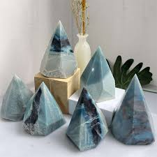

Chapter 7: Trolleite in Meditation & Spiritual Practice

Trolleite is considered one of the most powerful stones for meditation. Its high vibrational frequency helps quiet the mind and elevate awareness.

Meditation practice:

Hold a Trolleite palm stone or sphere.

Close your eyes and focus on your breath.

Visualize blue light surrounding you.

Set the intention to connect with your higher self or guides.

This crystal naturally induces a serene, spacious state, ideal for deep spiritual journeys.

Chapter 8: Rituals and Energy Work with Trolleite

Morning Ritual: Place Trolleite by your heart while affirming peace and clarity for the day.

Moon Rituals: Use Trolleite during full moons to release old patterns and welcome spiritual growth.

Energy Clearing: Place Trolleite in your space to cleanse stagnant energies and promote serenity.

Chapter 9: Trolleite in Crystal Grids

Trolleite works beautifully in grids for:

Spiritual awakening

Stress relief and tranquillity

Enhancing meditation spaces

Past-life healing

Pair with Amethyst for spiritual clarity, Selenite for angelic connection, or Clear Quartz for amplification.

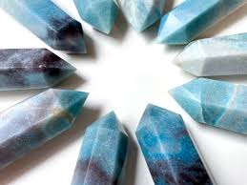

Chapter 10: Daily Practices with Trolleite

Carry a small stone in your pocket to stay calm during stressful moments.

Wear Trolleite jewellery to remain aligned with your higher self throughout the day.

Place Trolleite under your pillow to enhance dream recall and restful sleep.

Chapter 11: Caring for Your Trolleite

Cleansing: Use moonlight, sound healing, or smudging (avoid water if the stone has inclusions that may weaken it).

Charging: Place on a Selenite slab or in sunlight for brief periods.

Storage: Keep away from harsh chemicals or prolonged moisture.

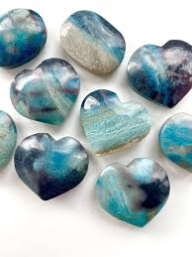

Chapter 12: Pairing Trolleite with Other Crystals

Lepidolite: For stress relief and emotional healing

Labradorite: For psychic awakening and protection

Selenite: For spiritual clarity and angelic guidance

Amethyst: For meditation and divine connection

Chapter 13: Affirmations for Working with Trolleite

Use affirmations while holding Trolleite to strengthen your intentions:

“I am calm, centred, and connected to my higher self.”

“I release all that no longer serves me.”

“I embrace peace, clarity, and spiritual growth.”

“My intuition is strong, and I trust my inner guidance.”

Chapter 14: Using Trolleite in Jewellery & Everyday Life

Trolleite jewellery not only looks stunning but also provides constant energetic support. Rings, pendants, and bracelets keep its vibration close to the body, aiding calm communication and intuitive awareness.

In everyday life, Trolleite can be placed on work desks for focus, near the bed for restful sleep, or in meditation corners for spiritual upliftment.

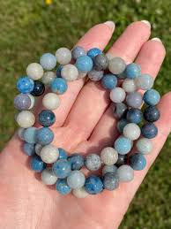

Chapter 15: Rare & Collectible Trolleite Varieties

Trolleite with Quartz: Amplifies spiritual properties

Trolleite with Lazulite: Enhances intuition and visionary states

High-Grade Brazilian Trolleite: Rich indigo tones prized by collectors

These rarer specimens are highly sought after by both collectors and spiritual practitioners.

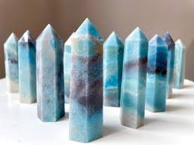

Chapter 16: Conclusion – Embracing Trolleite’s Energy

Trolleite is more than just a crystal; it is a spiritual companion on the path of awakening. With its calming yet expansive energy, it helps us transcend fear, stress, and limitation—guiding us toward higher states of peace and understanding.

By working with Trolleite daily—whether through meditation, ritual, or simply carrying it—you invite profound transformation into your life.

